Installing Apache
$ sudo apt update
$ sudo apt install apache2
$ sudo ufw app list
$ sudo ufw allow in "Apache"
$ http://your_server_ip
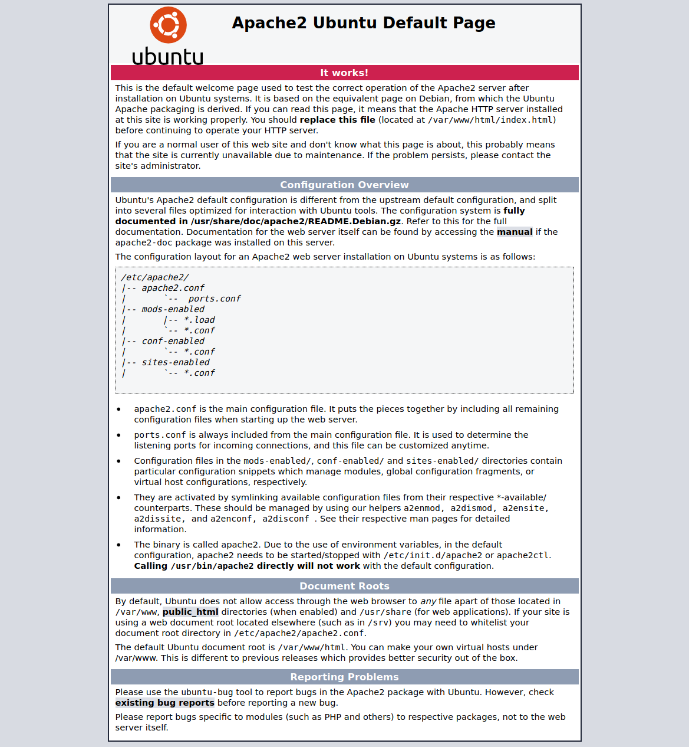

Installing MySQL
s$ udo apt install mysql-server
s$ udo mysql_secure_installation
$ sudo mysql
press y for yes
select 2 for password level.

Creating a Dedicated MySQL User and Granting Privileges
sudo mysql
CREATE USER 'aadesh'@'localhost' IDENTIFIED BY 'password
GRANT PRIVILEGE ON database.table TO 'aadesh'@'localhost';

give these permissions
GRANT CREATE, ALTER, DROP, INSERT, UPDATE, DELETE, SELECT, REFERENCES, RELOAD on *.* TO 'aadesh’@'localhost' WITH GRANT OPTION;

Now login with username and password
mysql -u aadesh -p
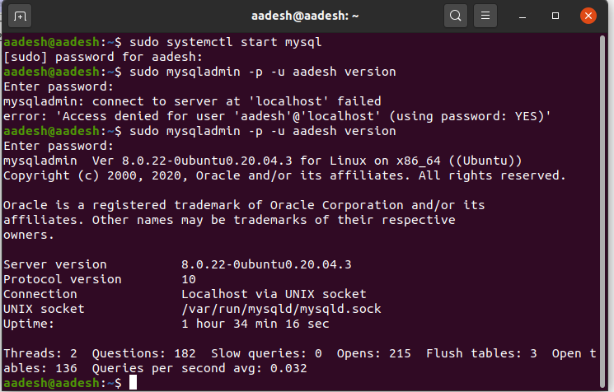

Installing PHP
$ sudo apt install php libapache2-mod-php php-mysql
$ php -v

make a file in /var/www/html/testphp.php and run in browser .
localhost/testphp.php

